**Home Equity Reverse Mortgage Information Technology**

**(HERMIT)**

**HERMIT System Changes – Release 5.2**

**Release Date: 11/19/16**

**Document Date: 12/05/16**

November 2016

Version 1.1

**INTRODUCTION**

The Home Equity Conversion Mortgage Service Provider (HECM SP) has released version 5.2 of the Home Equity Reverse Mortgage Information Technology (HERMIT) software which consists of:

* Updates to Monthly Lender Reconciliation File
* Standardize HERMIT search screens to include City, State, ZIP, and County
* 3rd Party FCL Terminate Transaction Code Changes
* Update Logic for Funded Date Changes
* Activate Block #121c for Claim Type 24 to claim debenture interest instead of using Block #408
* Release 2nd Timeline Auto-Create Changes
* New fields for HOA / Condo Assessments
* New Report for HOA / Condo Property Assessments
* Servicer MMIP batches over 20,000 records posted to HERMIT SFTP automatically
* Add City, State, Zip, and County to Reports
* Terminate Asset Sale Transaction
* Multiple "Assignment Denied / Payoff Issued" steps generate one Authorization record

If you have any questions regarding the functionality of the software release, please contact the HERMIT Help Desk at 561-899-2610 or at [servicingsupport@hermitsp.com](mailto:support@hecmsp.com). If you have any policy related questions, please send an email to HUD at [answers@hud.gov](mailto:answers@hud.gov).

## Updates to Monthly Lender Reconciliation File

Additional fields have been added to the Monthly Lender Reconciliation (MLR) file. An update has been made to the existing field Monthly Set-Aside “MO. SET-ASIDE” to display all Tax and Insurance (T&I) monthly set aside amounts. Previously, the field “MO. SET-ASIDE” was present but displayed zero for all loans.

The 16 fields added to the MLR file are existing fields in HERMIT and increases the number of fields in the MLR file from 64 fields to 80 fields. See below for the list of fields that have been added:

|  |  |
| --- | --- |
| **Field #** | **Field Name** |
| 65 | Round to 1/8th |
| 66 | ARM First Change Date |
| 67 | Credit Type |
| 68 | Loan Skey |
| 69 | Prop Charge-Pre D&P Balance |
| 70 | Payment Status |
| 71 | LESA Balance |
| 72 | LESA Type |
| 73 | Semi Annual Payment Amount |
| 74 | IDL Amount |
| 75 | IDL Expiration Date |
| 76 | HERMIT sub status |
| 77 | Current Principal Limit |
| 78 | NBS |
| 79 | Prior Loan Balance |
| 80 | CLOSE DT |

Figure 1: New MLR fields

The field Monthly Set-Aside “MO. SET-ASIDE” in the Monthly Lender Reconciliation (MLR) file has been updated to display all Tax and Insurance (T&I) monthly set aside amounts. Previously, the field was present but displayed zero for all loans.

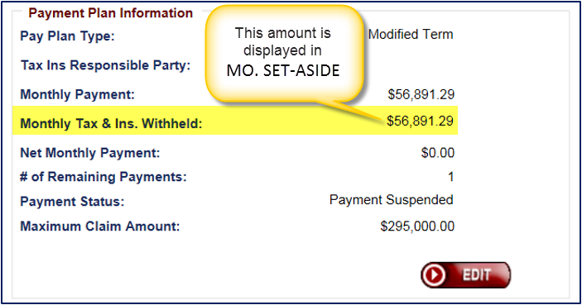

Figure 2: Loan Balance > Monthly T&I Withheld

Refer to HERMIT System & Resources page for updated Monthly Lender Reconciliation File Layout: <http://portal.hud.gov/hudportal/HUD?src=/program_offices/housing/comp/hecm_hermit>

## Standardize HERMIT search screens to include City, State, ZIP, and County

Previously, HERMIT search screens included the “Property State” field but only some search screens included “Property County” and none included “Property City” and “Property Zip”. An update was made to search screen pages, Loan Search Results, and Export to Excel results to include all four of the filters.

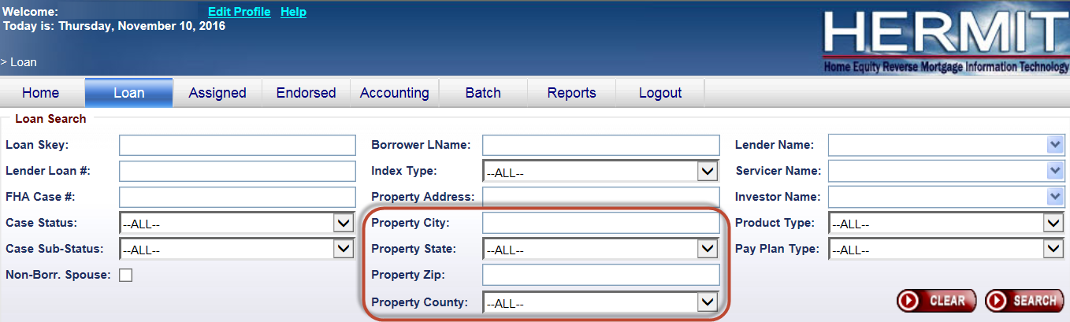

Figure 3: City, State, Zip, County added to Search Screens

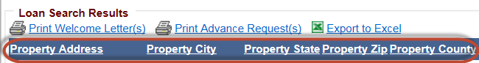

Figure 4: City, State, Zip, County added to Loan Search Results



Figure 5: City, State, Zip, County added to Export to Excel results

## 3rd Party FCL Terminate Transaction Code Changes

* + 1. Transaction code 2880 “Terminate - REO/3rd Party/FCL Sale (PIF)” has been renamed to “Terminate - 3rd Party FCL Sale(PIF)”. Functionality of this transaction code remains the same as before.

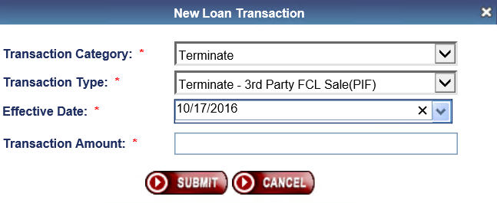

Figure 6: Selecting Renamed Transaction Code

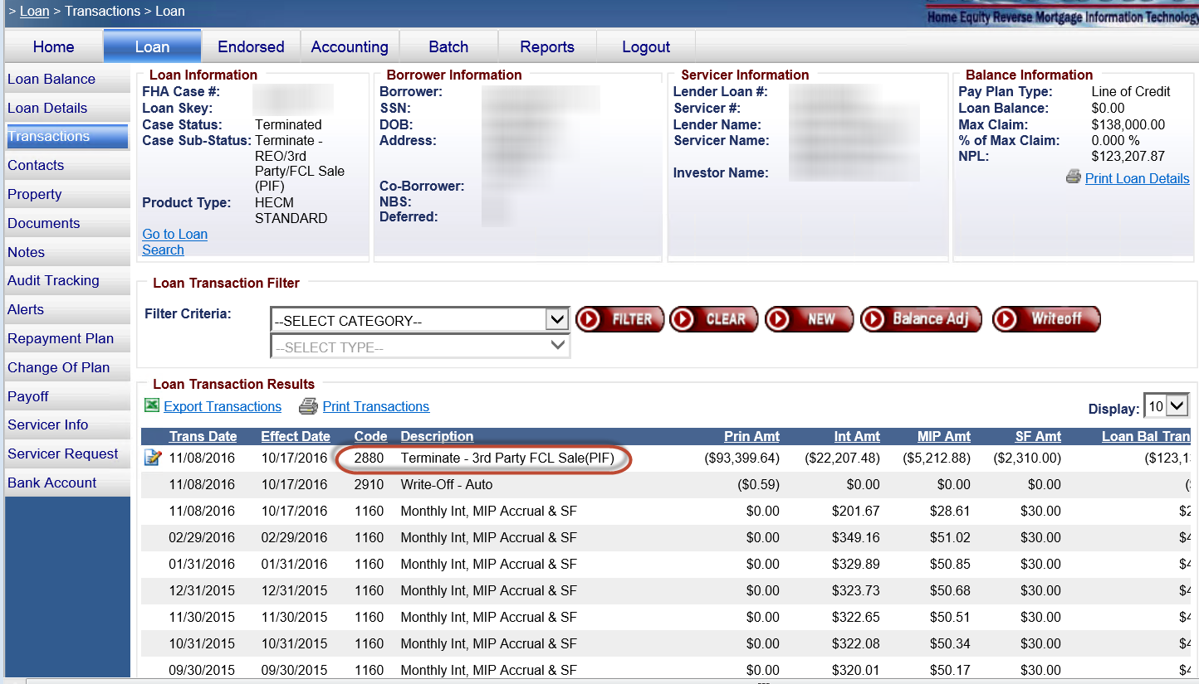

Figure 7: Example of Renamed Transaction

There is no change to the case sub-status description “Terminate – REO/3rd Party/FCL Sale (PIF)”.

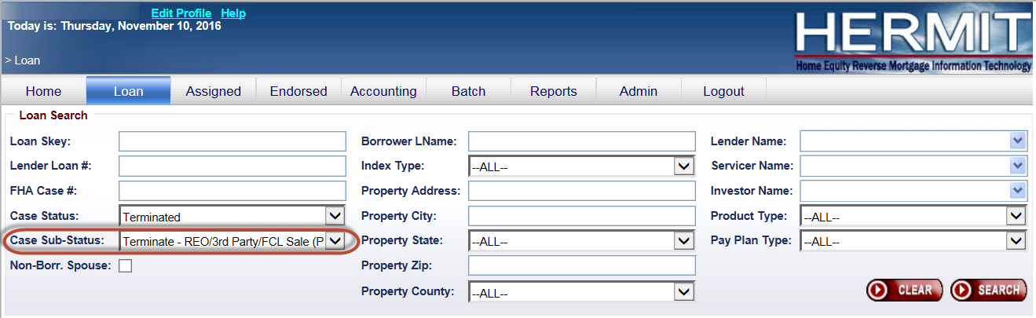

Figure 8: Case-Sub Status

* + 1. A new Transaction code and case sub-status have been created and are available to the HUD NSC contractor. Transaction Code 2886 “Terminate - 3rd Pty FCL Sale(PIF w/WOff)” can be posted on Assigned disposition loans. Entering this transaction will update the case status to Terminated and the new case sub-status “Terminate - 3rd Pty FCL Sale(PIF w/WOFF)” will be displayed.

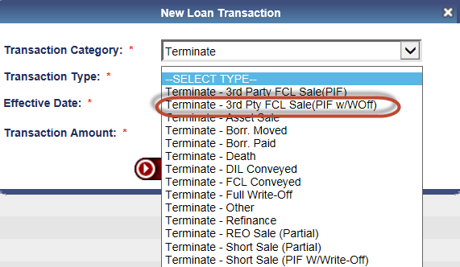

Figure 9: Terminate 3rd Pty FCL Sale(PIF w/WOff) Transaction

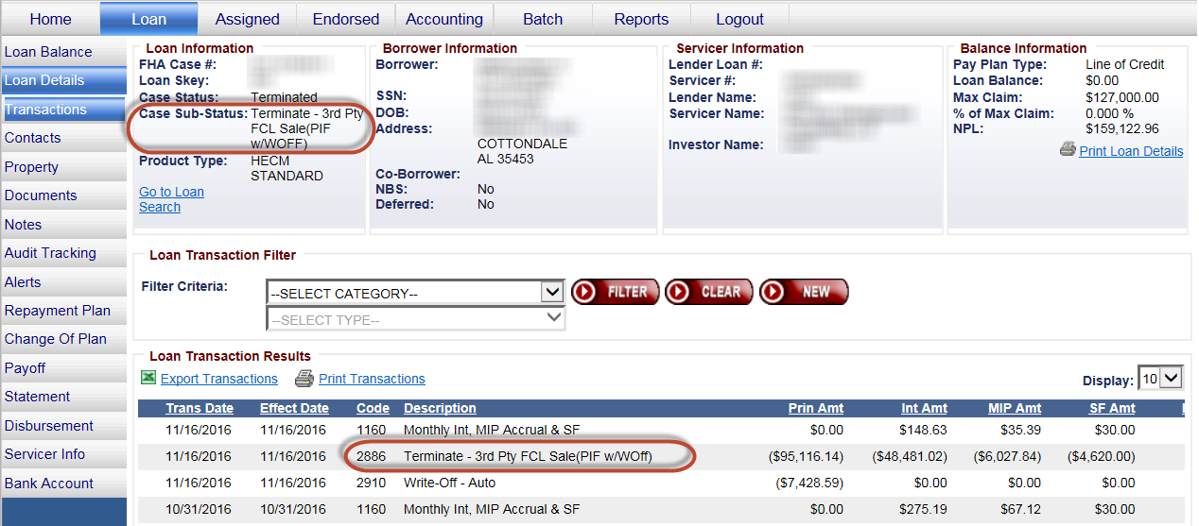

* Figure 10: New Case Sub-Status

## Update Logic for Funded Date Changes

Previously, when a user changed the funded date to a forward date in HERMIT, transactions with an effective date prior to the new funded date were adjusted off the loan. When a user would reenter the transactions that were adjusted off, late charges and penalty interest would be incurred. An update has been made to add a new pop-up window and to change the effective date on the existing transactions to the new funded date when there are transactions with an effective date prior to the new funded date. Late Charges and Penalty Interest will not be assessed as a result of moving existing transactions from the previous funded date to the new funded date. A loan recalculation of interest and MIP will still occur when the funded date is changed, same as before.

A new pop-up message will appear when the funded date is change that states “Transactions with an effective date prior to the new funded date were corrected and set to the new funded date.” The user clicks OK or Cancel.

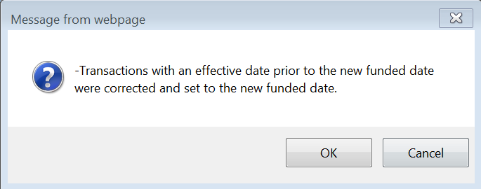

Figure 11: Pop Up Window

Loan > Transactions example of Before and After the Funded Date is changed

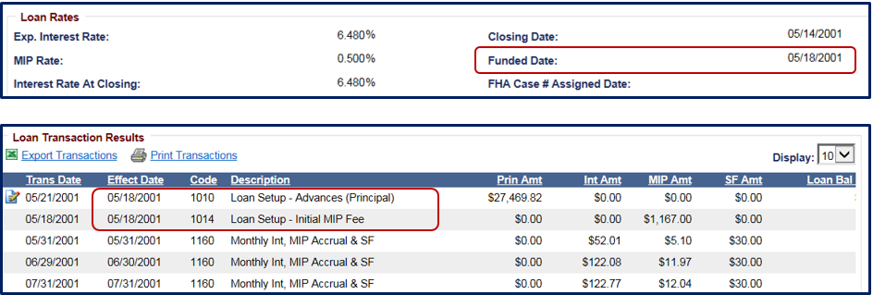

Figure 12: Loan > Transactions Before Funded Date is changed

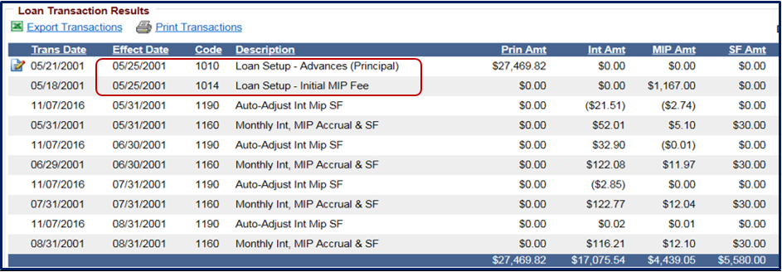

Figure 13: Loan > Transactions After Funded Date is changed

## Activate Block #121c on Claims Form 27011 for Claim Type 24 to claim debenture interest instead of using Block #408

Block #121c on Claim Type 24 is now editable. Amounts entered in Block #121c are included in the Net Claim Amount on the claims form and in the “Expense Amt” field on the Claims Detail Report. The Debenture Interest Difference amount entered in Block #121c of the Supplemental Claim form is included in the “Expenses” section of the AOP. This field is not subject to the MCA Limit Check.

The purpose is for servicers to use Block #121c for any Debenture Interest Difference amount instead of using Block #408 which is subject to the MCA limit check. This change will prevent allowable debenture interest from being capped due to exceeding the MCA limit check.

At the time of claim submission, Servicers will need to provide supporting documentation for the additional amount claimed in Block #121c.



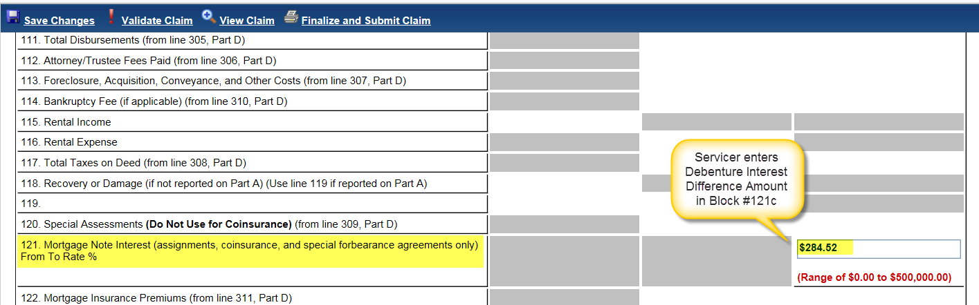

Figure 14: Block #121c

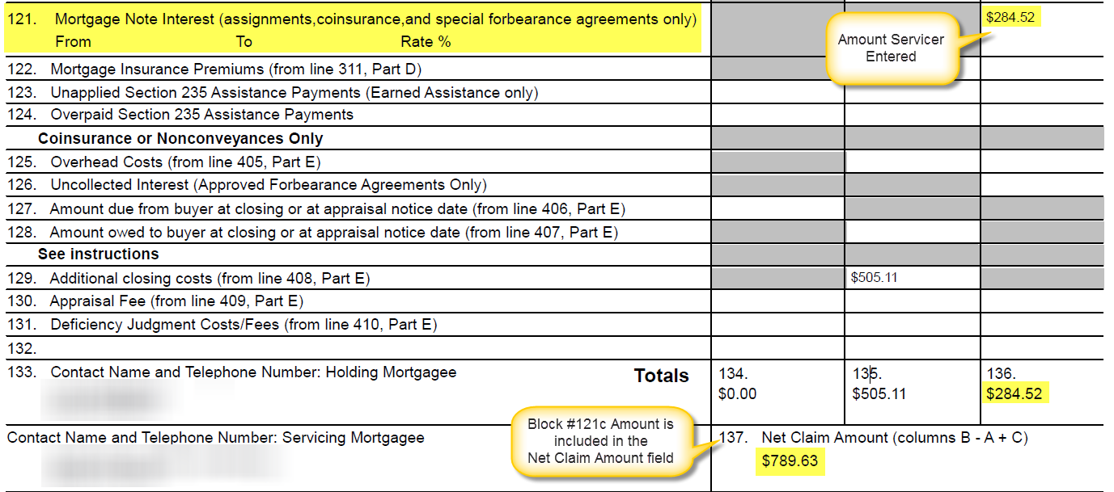

Figure 15: Expenses Section of Claims Form 27011



Figure 16: Claims Detail Report “Expense Amt”

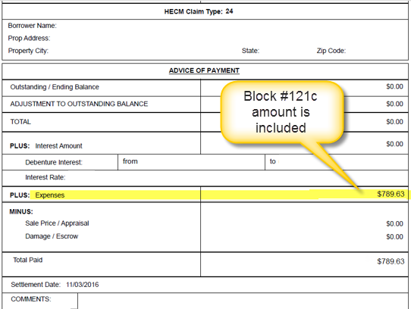

Figure 17: AOP “Expenses” section

## Release 2nd Timeline Auto-Create Changes

Changes to the auto creation of the Release 2nd timeline have been made. The Release 2nd Timeline will not be auto created upon Termination of a loan if any of the following apply:

* There is already an existing Active Release 2nd Timeline.
* Case Sub Status is “Terminate – CT 21”.
* Pay Plan Type is Lump Sum, Rate Type is Fixed, and FHA Case Number issued On or After 6/25/2014 (effective date of ML 2014-11).

In addition, the Release 2nd Timeline status has been updated to remain Active when a Termination transaction is adjusted or a loan is otherwise reopened. Previously, the timeline status was changed to Inactive.

No change was made to user roles that can manually create the Release 2nd Timeline.

## New fields for HOA / Condo Assessments

New fields have been added to HERMIT to capture information for properties that have Special Assessment Amounts from HOA or Condo associations. This information can be used to support tracking HOA and Condo foreclosures, as well as capture the contact information for the organization.

List of new data fields that can be captured for HOA and CONDO Assessment Information:

|  |  |  |
| --- | --- | --- |
| **Field #** | **Field Name** | **Description** |
| 1 | Contact Type | Required. Drop down field options are: CONDO, HOA |
| 2 | Association Name | Required |
| 3 | Term | Required. Drop down field options are: Annual, Semi-Annual, Quarterly, Monthly, Special |
| 4 | Assessment Amount | Required |
| 5 | Address 1 | Optional |
| 6 | Address 2 | Optional |
| 7 | City | Optional |
| 8 | State | Optional |
| 9 | ZIP | Optional |
| 10 | Phone Number | Optional |

Figure 18: New Assessment Information Fields

The location to input and view the Assessment Information is found on the Loan > Contacts screen under a new section named “Assessment Information”. All of the information entered on the Assessment Information screen can be viewed in the same location it was entered as well as on a new report named “Property Assessments”.

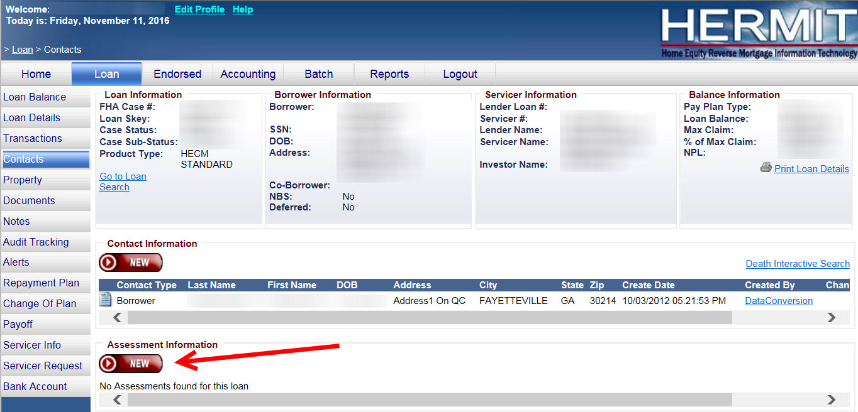

Figure 19: View Assessment Information

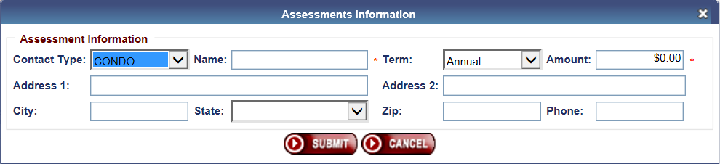

Figure 20: Assessment Information Entry screen

After Assessment Information is entered on a loan the “Assessment Type” is displayed on the Loan > Property Information screen. The value in the field will be populated based on the Contact Type entered in the Assessment Information section. For Contact Type “HOA” the field displays “HOA”. For Contact Type “Condo” the field displays “Condo”. For at least one of each Contact Type “HOA” and “Condo” on the same loan, the field displays CONDO/HOA. For loans with no Assessment Information entered the field is blank.

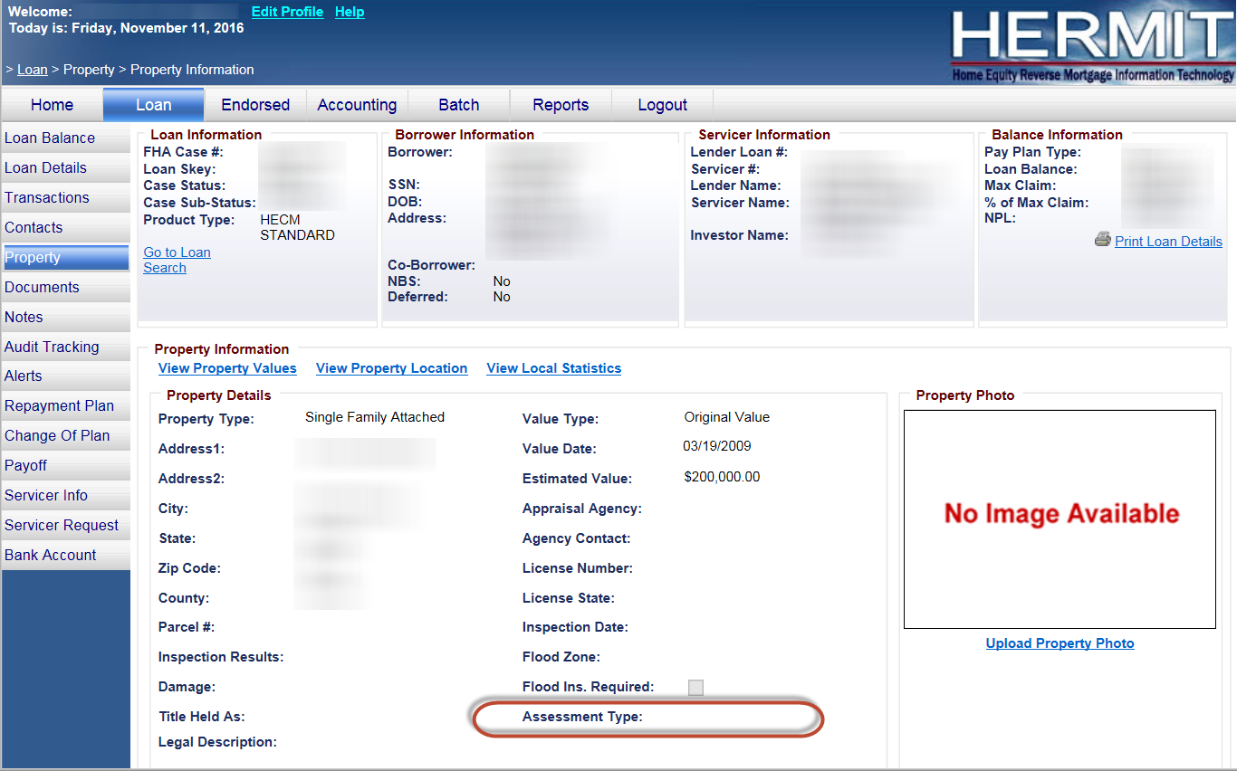

Figure 21: Property Info – Assessment Type

## New Report for HOA / Condo Property Assessments

A new report named “Property Assessments” has been added to the HERMIT Reports page which displays the information from these new fields.

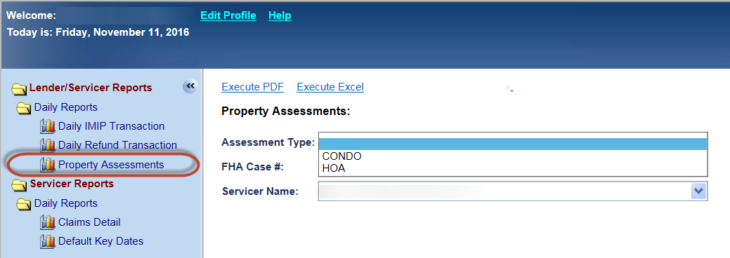

Figure 21: Property Assessments Report

See below for the list of fields on the Property Assessments Report:

|  |  |
| --- | --- |
| **Column** | **Field Name** |
| A | loan_servicer_skey |
| B | loan_servicer_name |
| C | fha_case_no |
| D | borrower_first_name |
| E | borrower_last_name |
| F | assessment_term_skey |
| G | assessment_term_desc |
| H | assessment_type_skey |
| I | assessment_type_desc |
| J | loan_status |
| K | loan_status_desc |
| L | loan_sub_status_code |
| M | loan_sub_status_desc |
| N | assessment_amount |
| O | association_name |
| P | association_address |
| Q | association_city |
| R | association_state |
| S | association_zip |
| T | association_phone_no |

Figure 22: Property Assessments Report fields

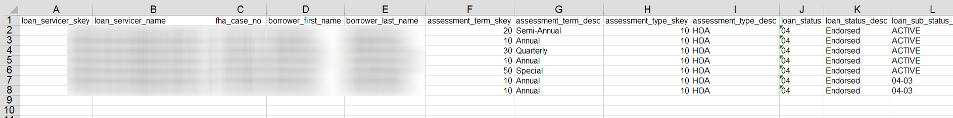

Figure 23: Property Assessments Report Output

## Servicer MMIP batches over 20,000 records posted to HERMIT SFTP automatically

Batch Details for Batch Type “Monthly MIP Due” is found in HERMIT on the Accounting > Transmittals screen. When there are more than 20,000 records in a single batch, the system does not allow the batch details to be displayed. For servicers that had previous arrangements to receive these files, the detail for these batches will be automatically generated and saved to each respective servicer’s HERMIT SFTP server.

On a weekly basis, batches with more than 20k records (including MMIP adjustments) will have Batch Details posted to the servicer’s HERMIT SFTP “Lender_Reconciliation” folder by end of day each Monday for batches created from the previous Monday through Sunday. If there are multiple batches with more than 20k records in the date range for the same servicer, separate files will be produced for each batch. If there are no batches with more than 20k records for the date range, no file will be generated and servicers can acquire all necessary details through the Accounting > Transmittals page.

The file layout is the same as the Batch Details from the Accounting > Transmittals page

|  |  |
| --- | --- |
| **Column** | **Field Name** |
| A | FHA Case # |
| B | Trans Date |
| C | Eff Date |
| D | Code |
| E | Description |
| F | MIP Amt |
| G | PI Amt |
| H | LC Amt |
| I | Prin Amt |
| J | Int Amt |
| K | Sf Amt |
| L | Claim Amt |
| M | Corp Adv Amt |
| N | Loss Draft Amt |
| O | Trans Total |
| P | Create Date |
| Q | Changed By |

Figure 24: File Layout MMIP batches over 20k

## Add City, State, Zip, and County to Reports

Reports in the Assigned Notes Reports/Daily Reports section have been updated to standardize the Property Address, City, State, Zip, and County. Where the Property address field previously included the City, State, and Zip; the fields have been placed into specific report columns for each category.

The following reports were affected:

1. Closed Loan Files
2. Foreclosure Activity Listing
3. HECM Foreclosure
4. Missing Loan Document Detail
5. Needs Custodial Care
6. Placed in Custodial Care

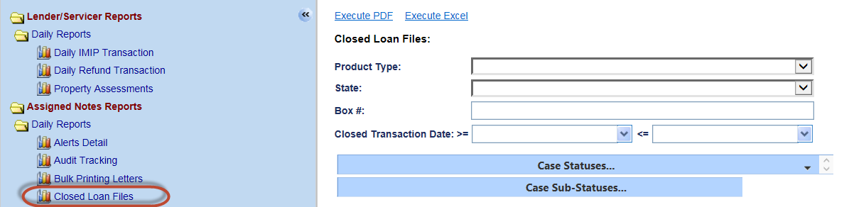

Figure 25: Example - Closed Loan File Report Search



Figure 26: Example - Closed Loan File Report Results

## Terminate Asset Sale Transaction

A new Transaction code and case sub-status have been created and are available to the HUD NSC contractor. Transaction Code 2883 “Terminate - Asset Sale” can be posted on Assigned loans. Entering this transaction will update the case status to Terminated and the new case sub-status “Terminate - Asset Sale” will be displayed.

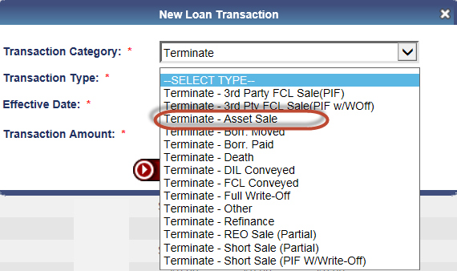

Figure 27: Terminate - Asset Sale Transaction

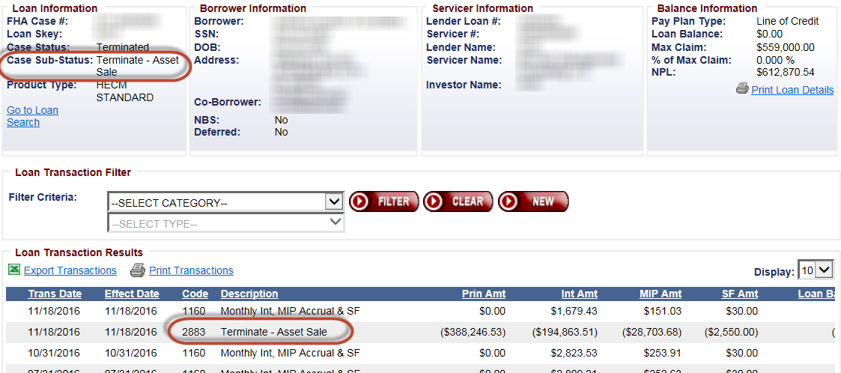

* Figure 28: Terminate - Asset Sale Case Sub-Status

## Multiple "Assignment Denied / Payoff Issued" steps generate one Authorization record

An update has been made on the Accounting > Authorizations page to display only one record for Approval when multiple “Assignment Denied / Payoff Issued” timeline steps are added to the “Request for HUD Advance (Assignment)” timeline. Previously, the Accounting > Authorizations page displayed one entry for each “Assignment Denied / Payoff Issued” timeline steps, resulting in multiple Authorization records displayed on the Accounting > Authorizations page.

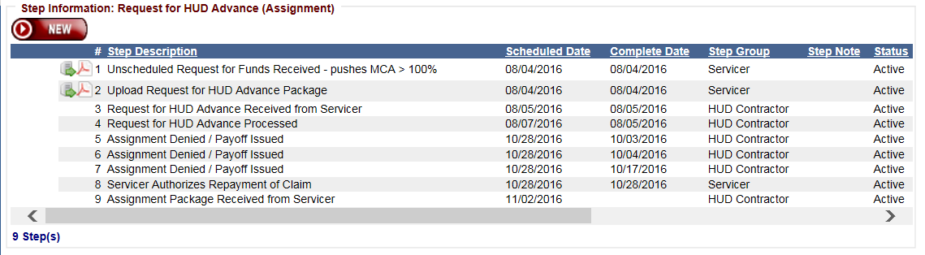

* Figure 29: Multiple Assignment Denied / Payoff Issued steps

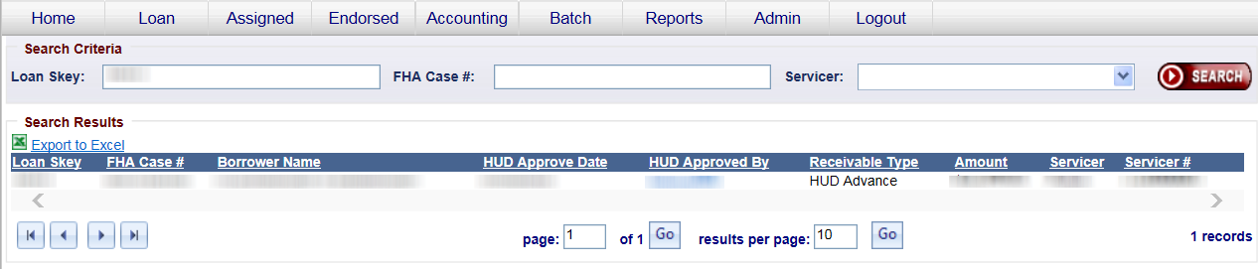

* Figure 23: One Accounting > Authorizations record